**Sprint-1**

|  |  |
| --- | --- |
| Date | 7 November 2022 |
| Team ID | PNT2022TMID34904 |
| Project Name | Industry-Specific Intelligent Fire Management System |

**Display the temperature values:**

Submitted by: Nandhini,parwin,preethi,Rathidevi,Sathya

Student Roll number:810419104067,810419104078,810419104091,810419104094,810419104-100 Wokwi link: <https://wokwi.com/projects/347571790373978706>

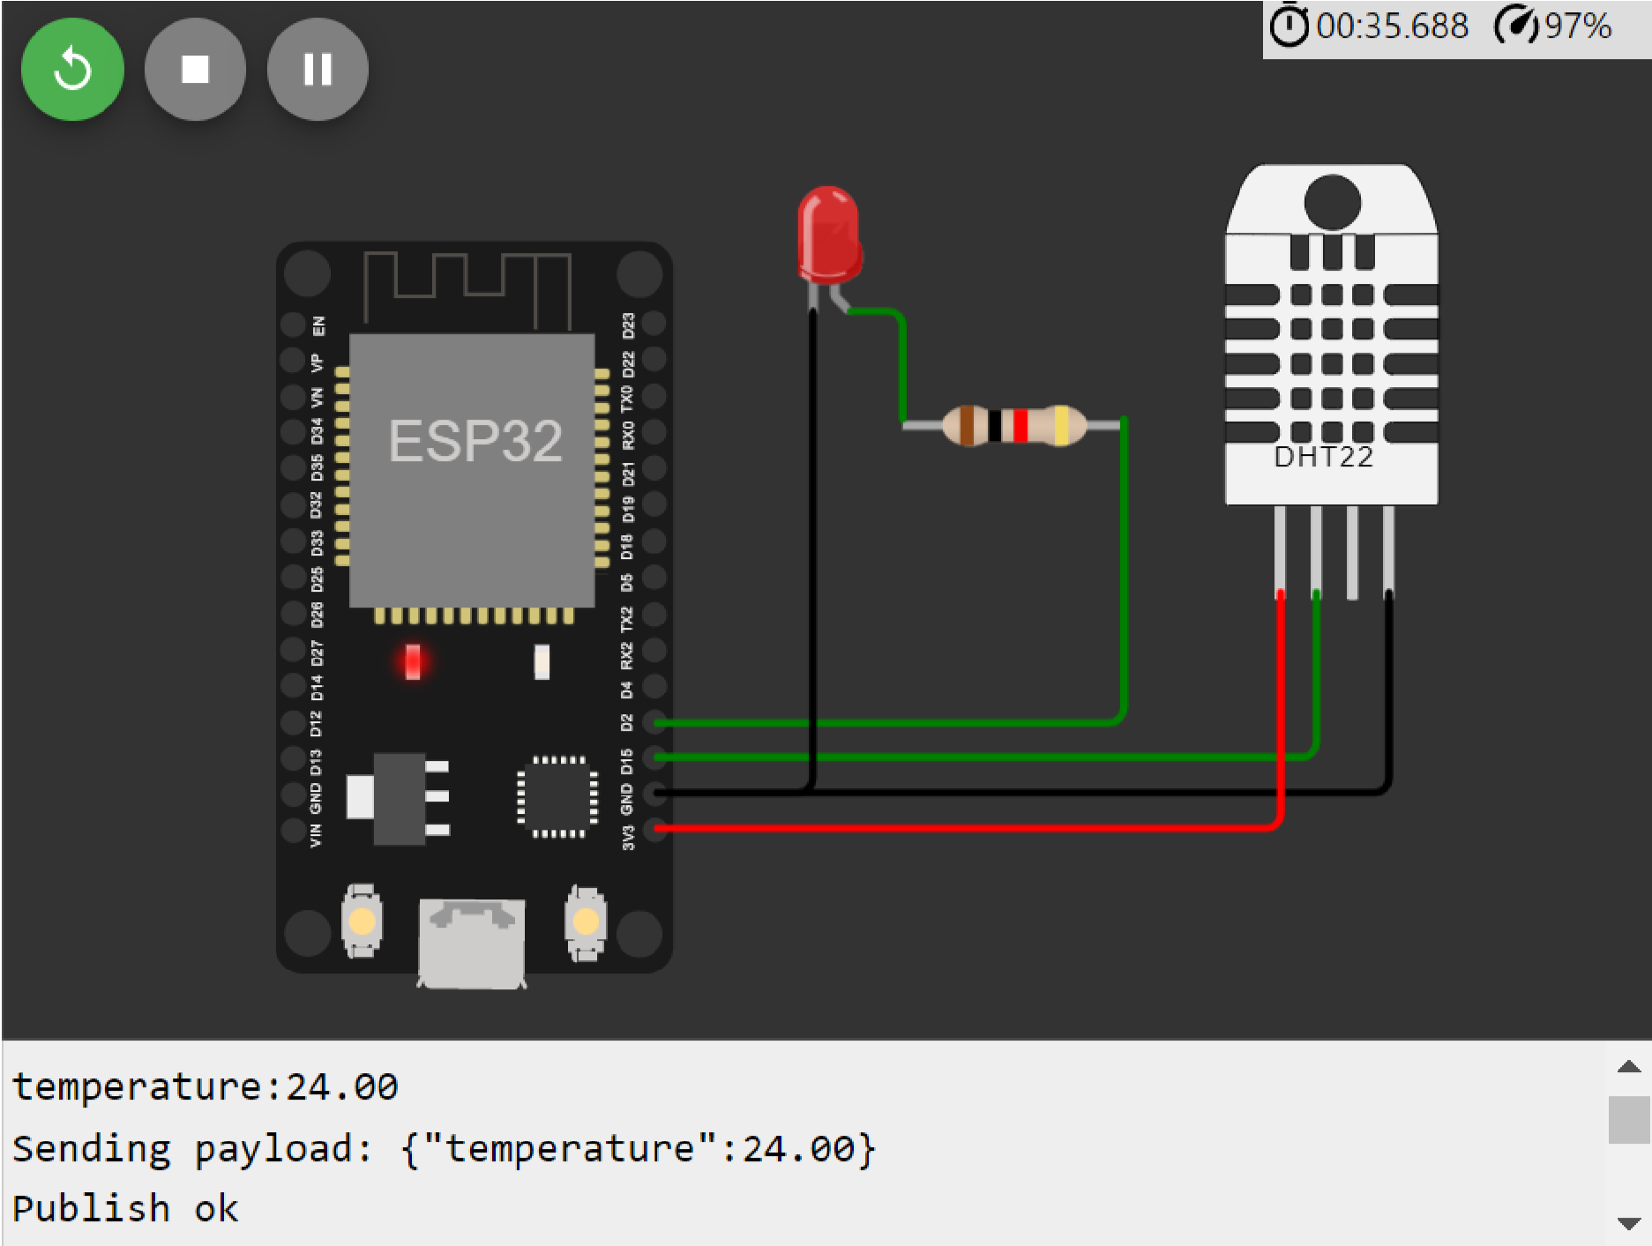

**Program:**

#include <WiFi.h>//library for wifi

#include <PubSubClient.h>//library for MQtt

#include "DHT.h"// Library for dht11

#define DHTPIN 15 // what pin we're connected to

#define DHTTYPE DHT22 // define type of sensor DHT 11

#define LED 2

DHT dht (DHTPIN, DHTTYPE);// creating the instance by passing pin and typr of dht connected

void callback(char* subscribetopic, byte* payload, unsigned int payloadLength);

//-------credentials of IBM Accounts------

#define ORG "zbgr67"//IBM ORGANITION ID

#define DEVICE_TYPE "fershidevicetype"//Device type mentioned in ibm watson IOT Platform

#define DEVICE_ID "fershideviceid"//Device ID mentioned in ibm watson IOT Platform

#define TOKEN "fershiageona" //Token String data3; float t;

//-------- Customise the above values --------

char server[] = ORG ".messaging.internetofthings.ibmcloud.com";// Server Name

char publishTopic[] = "iot-2/evt/Data/fmt/json";// topic name and type of event perform and format in which data to be send

char subscribetopic[] = "iot-2/cmd/command/fmt/String";// cmd REPRESENT command type AND COMMAND IS TEST OF FORMAT STRING char authMethod[] = "use-token-auth";// authentication method char token[] = TOKEN; char clientId[] = "d:" ORG ":" DEVICE_TYPE ":" DEVICE_ID;//client id

//-----------------------------------------

WiFiClient wifiClient; // creating the instance for wificlient

PubSubClient client(server, 1883, callback ,wifiClient); //calling the predefined client id by passing parameter like server id,portand wificredential void setup()// configureing the ESP32

{

**Serial**.begin(115200); dht.begin(); pinMode(LED,OUTPUT); delay(10); **Serial**.println(); wificonnect(); mqttconnect();

} void loop()// Recursive Function

{

t = dht.readTemperature();

**Serial**.print("temperature:");

**Serial**.println(t);

PublishData(t); delay(1000); if (!client.loop()) { mqttconnect();

}

}

/*.....................................retrieving to

Cloud...............................*/

void PublishData(float temp) { mqttconnect();//function call for connecting to ibm

/* creating the String in in form JSon to update the data to ibm cloud

*/

String payload = "{\"temperature\":"; payload += temp; payload += "}";

**Serial**.print("Sending payload: ");

**Serial**.println(payload);

if (client.publish(publishTopic, (char*) payload.c_str())) {

**Serial**.println("Publish ok");// if it sucessfully upload data on the cloud then it will print publish ok in Serial monitor or else it will print publish failed

} else {

**Serial**.println("Publish failed");

}

} void mqttconnect() { if (!client.connected()) {

**Serial**.print("Reconnecting client to "); **Serial**.println(server); while (!!!client.connect(clientId, authMethod, token)) { **Serial**.print("."); delay(500);

} initManagedDevice();

**Serial**.println();

} } void wificonnect() //function defination for wificonnect {

**Serial**.println();

**Serial**.print("Connecting to ");

WiFi.begin("Wokwi-GUEST", "", 6);//passing the wifi credentials to establish the connection while (WiFi.status() != WL_CONNECTED) { delay(500);

**Serial**.print(".");

}

**Serial**.println("");

**Serial**.println("WiFi connected");

**Serial**.println("IP address: "); **Serial**.println(WiFi.localIP());

} void initManagedDevice() { if (client.subscribe(subscribetopic)) { **Serial**.println((subscribetopic));

**Serial**.println("subscribe to cmd OK");

} else {

**Serial**.println("subscribe to cmd FAILED");

}

}

void callback(char* subscribetopic, byte* payload, unsigned int payloadLength)

{

**Serial**.print("callback invoked for topic: "); **Serial**.println(subscribetopic); for (int i = 0; i < payloadLength; i++) { //Serial.print((char)payload[i]); data3 += (char)payload[i];

}

**Serial**.println("data: "+ data3); if(data3=="lighton")

{

**Serial**.println(data3); digitalWrite(LED,HIGH);

} else

{

**Serial**.println(data3); digitalWrite(LED,LOW);

} data3="";

}

**Displaying flame sensor values:**

Submitted by:Godsy D,Aswini A

Student Roll no:962819106016,962819106008

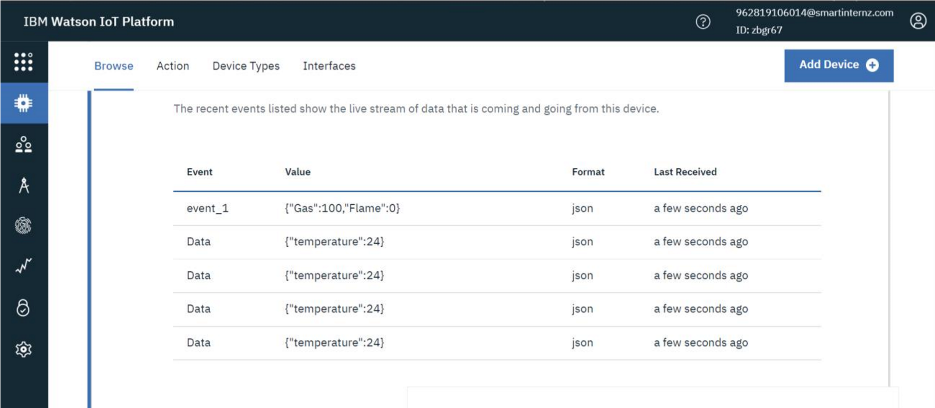

**Code:**

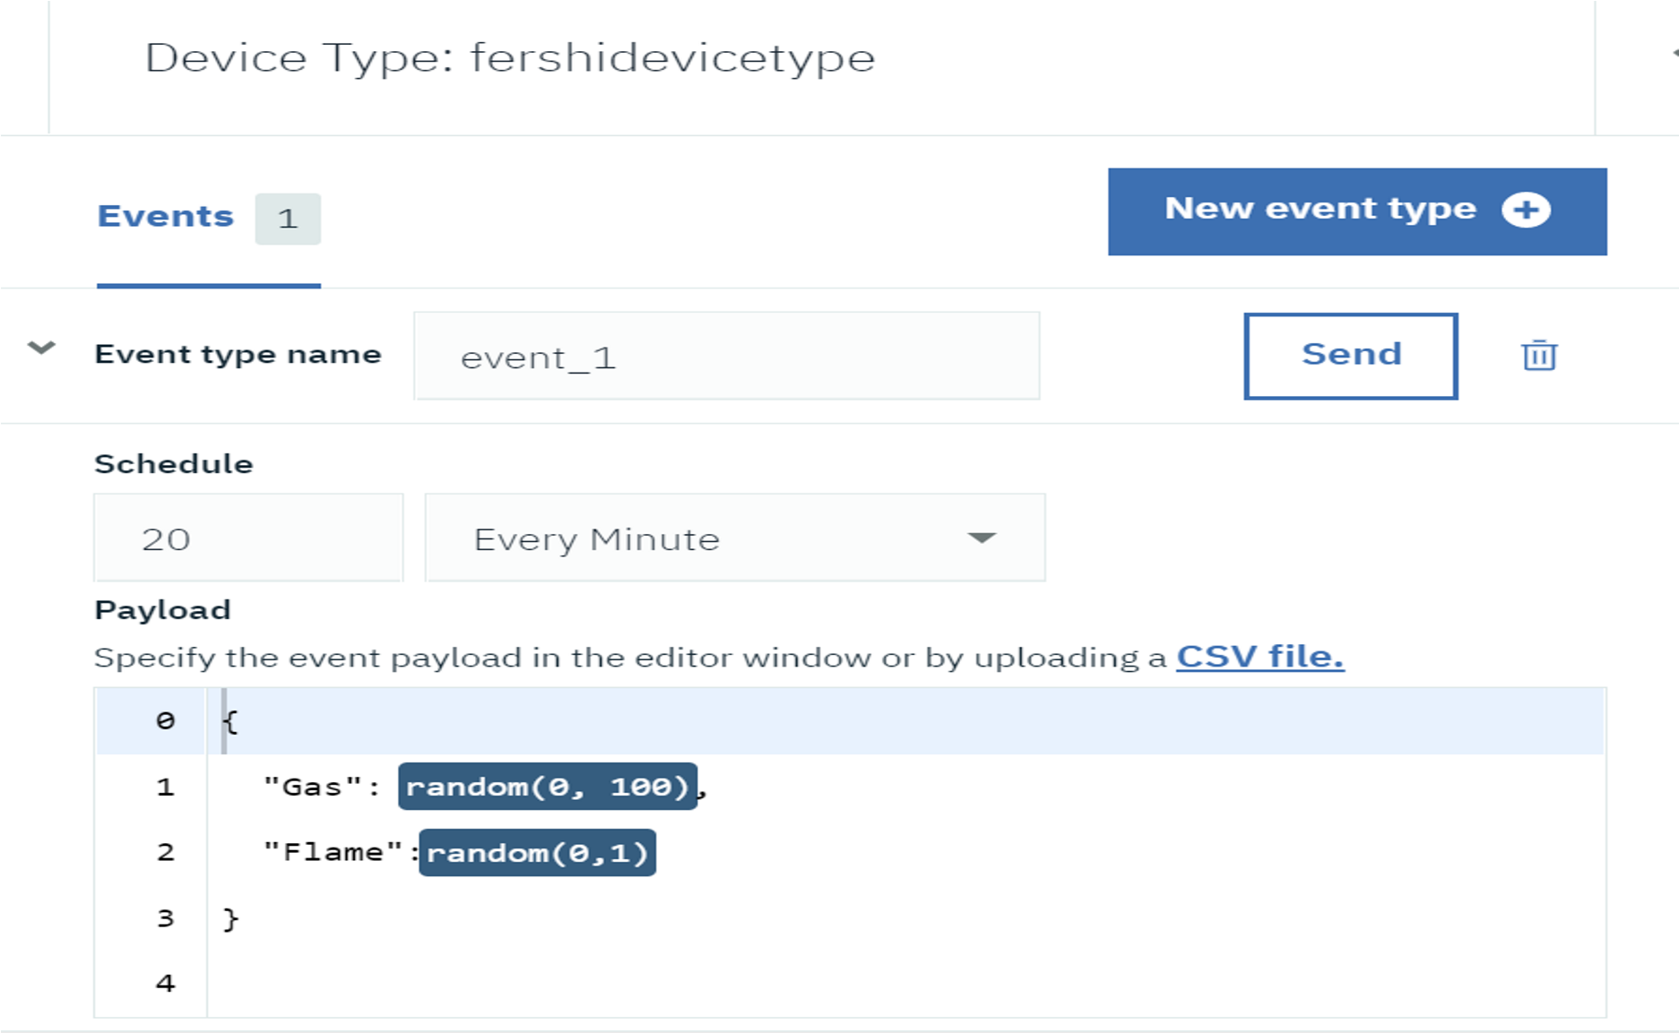

**Displaying gas sensor values:**

Submitted by:Fershia G Geona, Reshma Xavier

Student Roll number:962819106014,962819106033

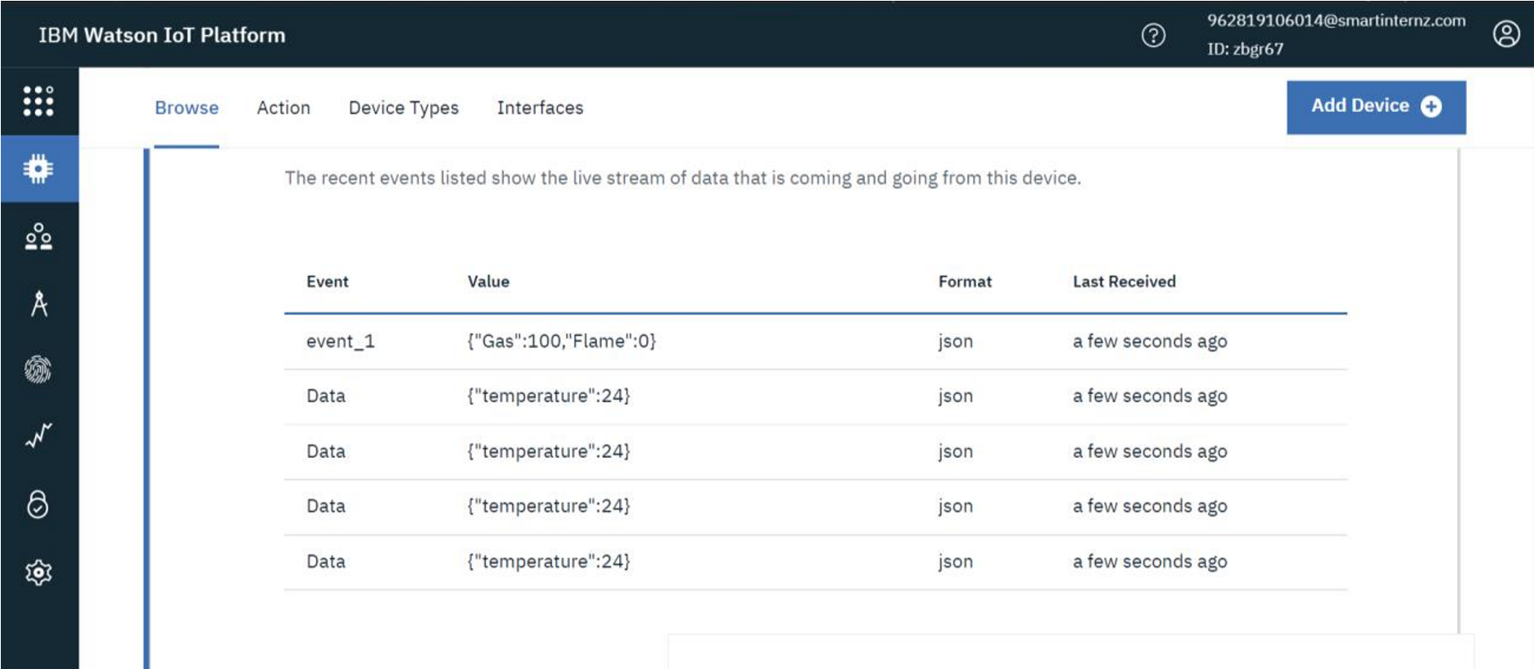

**Code:**

